Frontend Test Cases

for

Wellness Quest

Team: GitHub Issues
Author: Ari Le
Capstone Project Spring, 2024
The University of West Florida

March 7th, 2024

CIS 4595: Capstone Project
Dr. Bernd Owsnicki-Klewe

Table of Contents
Table of Contents 3
1 User Registration 4
Test case 1.1: User Registration 4
Test case 1.2: Invalid email address for User Registration 4
Test Case 1.3: Invalid password for User Registration 5
Test case 1.4: No email address for User Registration 5
Test case 1.5: No password for User Registration 6
Test case 1.6: No username for User Registration 6
Test case 1.7: No first name for User Registration 6
Test case 1.8: No last name for User Registration 7
2 User Profile 7
Test Case 2.1: View User Profile 7
3 Activity Tracking 7
Test case 3.1: View Past Activities 7
4 GPS Tracking 8
Test case 4.1: GPS Tracking Integration 8
5 Challenges Management 11
Test case 5.1: View Points for Each Challenge 11

List of Figures
Figure 1 - Warning 1 11
Figure 2 - Warning 2 11

1 User Registration

Test case 1.1: User Registration
- Objective: To verify that users can successfully register for an account.
- Preconditions:
- User navigates to the registration page.
- Valid email address: an email address must have the format “example@example.com” and be unique.
- Valid password: A password must be at least 8 characters long and contain at least one uppercase letter, one lowercase letter, one digit, and one special character.
- Test Steps:
- Enter valid email address and password.
- Click on the “Register” button.
- Expected Result: User is registered successfully and directed to the profile page.

Test case 1.2: Invalid email address for User Registration
- Objective: To verify that the application handles invalid input gracefully.
- Preconditions:
- User navigates to the registration page.
- Invalid email address: an invalid email address does not adhere to the format “example@example.com” (e.g., fakeAddr, fake.uwf, etc.).
- Valid password: A valid password as defined in Test Case 2.1.
- Test Steps:
- Enter an invalid email address and a valid password.
- Click on the “Register” button.
- Expected Result: User receives an error message indicating the issue with the input data.

Test Case 1.3: Invalid password for User Registration
- Objective: To verify that the application handles invalid input gracefully.
- Preconditions:
- User navigates to the registration page.
- Valid email address: A valid email address as defined in Test Case 2.1.
- Invalid password: An invalid password that does not meet the required criteria as listed in Test Case 2.1 (e.g., 1234, password, etc.)
- Test Steps:
- Enter a valid email address and an invalid password.
- Click on the “Register” button.
- Expected Result: User receives an error message indicating the issue with the input data.

Test case 1.4: No email address for User Registration
- Objective: To verify that the application handles no input entered gracefully.
- Preconditions: User navigates to the registration page.
- Test Steps:
- Click on the “Register” button without providing an email address.
- Expected Result: User receives an error message indicating they must enter their email address to register.

Test case 1.5: No password for User Registration
- Objective: To verify that the application handles no input entered gracefully.
- Preconditions: User navigates to the registration page.
- Test Steps:
- Click on the “Register” button without providing a password.
- Expected Result: User receives an error message indicating they must enter a password to register.

Test case 1.6: No username for User Registration
- Objective: To verify that the application handles no input entered gracefully.
- Preconditions: User navigates to the registration page.
- Test Steps:
- Click on the “Register” button without providing a username.
- Expected Result: User receives an error message indicating they must enter a username to register.

Test case 1.7: No first name for User Registration
- Objective: To verify that the application handles no input entered gracefully.
- Preconditions: User navigates to the registration page.
- Test Steps:
- Click on the “Register” button without providing a first name.
- Expected Result: User receives an error message indicating they must enter a first name to register.

Test case 1.8: No last name for User Registration
- Objective: To verify that the application handles no input entered gracefully.
- Preconditions: User navigates to the registration page.
- Test Steps:
- Click on the “Register” button without providing a last name.
- Expected Result: User receives an error message indicating they must enter a last name to register.

2 User Profile

Test Case 2.1: View User Profile
- Objective: To verify that users can view their profile information after logging in.
- Preconditions: User is logged into the application.
- Test Step:
- Navigate to the profile page.
- Expected Result: User’s information, including user name, current challenges, current level, and XP, is displayed correctly.

3 Activity Tracking

Test case 3.1: View Past Activities
- Objective: To verify that users can view the challenges they have finished.
- Preconditions:
- User is logged into the application.
- User participated in and finished at least one challenge.
- Test Step:
- Navigate to the history page.
- Expected Result: User’s past challenges, including the name of the challenge, the description of the challenge, and the XP of the challenge, are displayed correctly.

4 GPS Tracking

Test case 4.1: GPS Tracking Integration
- Objective: To verify that the GPS tracking functionality is seamlessly integrated into the app’s interface and provides real-time distance updates during workout sessions.
- Preconditions:
- User is logged into the application.
- User enables GPS for the application.
- User starts a challenge.
- Test steps:
- Start moving accordingly to the challenge.
- Check if the progress bar of the started challenge is updating while the user is doing the challenge.
- Check if the progress bar of the started challenge stops updating when the user stops moving.
- Check if the challenge is marked finished if the progress bar is full.
- Expected Result:
  - The app should provide real-time updates of the distance traveled, accurately reflecting the user’s movements.
  - The app should update the challenge progress accordingly to the distance traveled by the user.
- Defect Report:
    - Description:
      - The progress bar does not fill up until the application is reloaded after syncing data.
      - Upon reloading the application to reflect the completed challenge, two warnings appear on the screen of the Android emulator.
    - Steps to reproduce:
      - Start a challenge with small goal such as 250.
      - Set the first location using the Android emulator’s GPS location feature.
      - Press “Sync data” to update the location on the server side.
      - Set the second location that is further away from the first location, make sure it’s farther than it’s needed to be to complete the challenge.
      - Press “Sync data” to update the location on the server side again.
      - Observer the progress bar behavior.
      - Reload the app to reflect the completed challenge. (Press ‘r’ on the console you used to start the frontend)
    - Expected behavior:
      - The progress bar should fill up immediately after syncing data.
      - No warnings should appear upon reloading the application after completing the challenge.
    - Observed behavior:
      - The progress bar does not fill up until the application is reloaded.
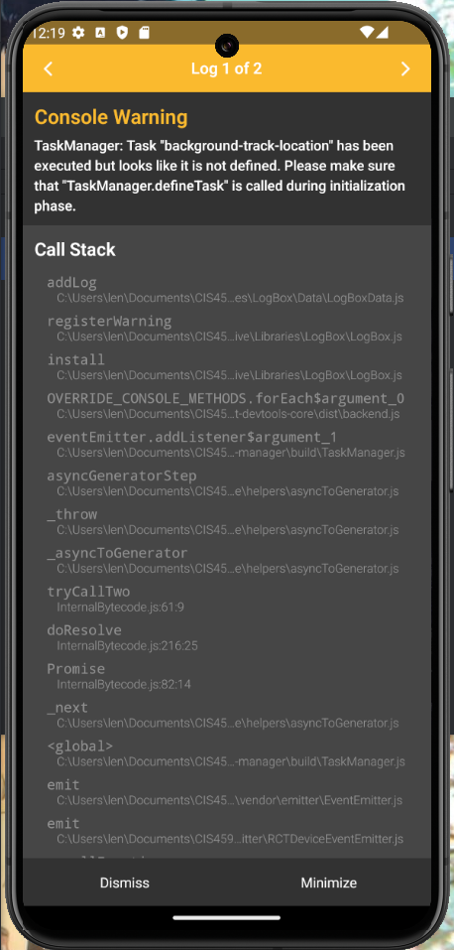
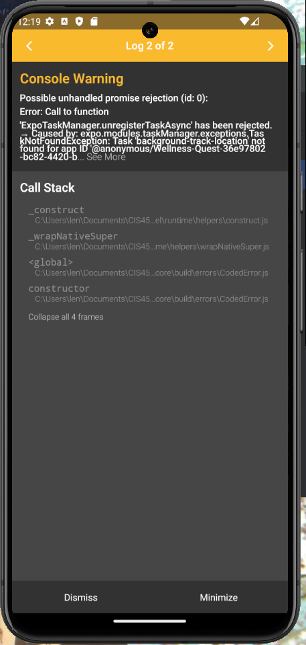
      - Two warnings appear on the screen after reloading the application to reflect the completed challenge.
Figure 1 - Warning 2
Figure 2 - Warning 1

    - Severity: Medium
    - Status: Open

5 Challenges Management

Test case 5.1: View Points for Each Challenge
- Objective: To verify that users can view the points they will gain for each challenge.
- Preconditions:
- User is logged into the application.
- Test steps:
- User navigates to the challenge page.
- On the challenge page the user will see a list of available challenges.
- Expected Result: The challenge page shows a list of available challenges. Each challenge component shows the points/XP the user will gain if the user chooses to participate in this challenge.

